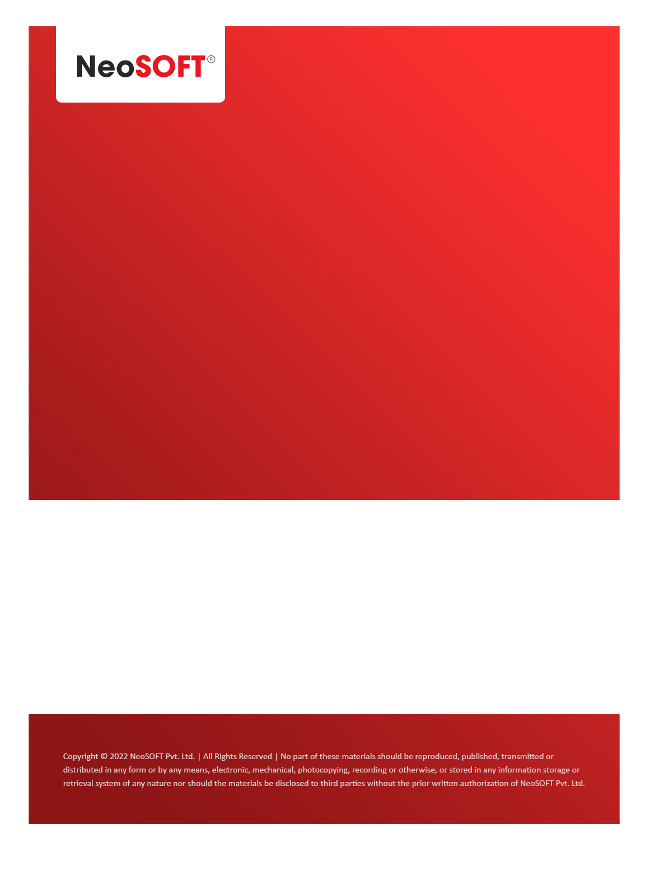`

**Eltizam MOM – Wireframes Review Meeting**

Eltizam

Client Name

NeoSOFT is a SEI-CMMI Level-5 Global IT Consulting & Software Solutions Provider

**April 07**, 2023

|  |  |
| --- | --- |
| **Meeting Date, Time, and Attendee Details** | |
| **Date** | 7th April 2023 |
| **Venue** | MS Teams |
| **Time** | 05.30 PM – 06.30 PM IST |
| **Meeting Type** | Wireframes discussion |
| **Internal Attendees** | * YallaReddy * Akshata Shinde |
| **Client Attendees** | * Karuna Pawar * Vinod Kumar * Khateeb |
| **Presented By** | * Akshata Shinde |
| **MOM Prepared By** | * YallaReddy |

|  |  |
| --- | --- |
| **Details of Meeting** | |
| **Sr. No.** | **Description** |
| 1 | Akshata presented wireframe ready as of today to Eltizam team. |
| 2 | With help of Vinod & Karuna, we discussed screen by screen. Also, Vinod suggested changes in couple screen for data field, missing details. |
| 3 | Akshata have the request changes list and we will work on those changes on wireframe. We will try to submit these changes by Monday/Tuesday. |
| 4 | Vinod suggested to add Menus first to make it present to stakeholder and then asked to pick suggested changes on existing wireframes |
| 5 | Had discussion with Khateeb on Angular UI adoption from .Net forms. He wants to understand why we are coming with extra hours & new CR. So, we told that will talk internally and update on it. |

|  |  |  |  |  |  |
| --- | --- | --- | --- | --- | --- |
| **Actionable** | | | | | |
| **Sr. No.** | **Action Item** | **Assigned to** | **Assigned Date** | **Expected Completion Date** | **Status** |
| 1 | Akshata will work on suggested changes of Menus & existing pages and submits. | Akshata | 7th Apr | 11th Apr |  |
|  |  |  |  |  |  |
|  |  |  |  |  |  |